Debunking Astronomical Pseudo-Science:
A Brief List of Resources on the Web
by Andrew Fraknoi (Fromm Institute, U. of San Francisco)

© copyright 2021 Andrew Fraknoi. The right to reproduce for any non-commercial educational purpose is hereby granted, as long as the author’s name and institution are not deleted.
For any other use, contact the author at: fraknoi {at} fhda {dot) edu

This short list, limited to sources available on the Internet, is designed to help you examine, with a skeptical eye, some of the specific claims at the fringes of science that are related to astronomy. At the end are some more general resources for addressing pseudo-science in a fact-based way.

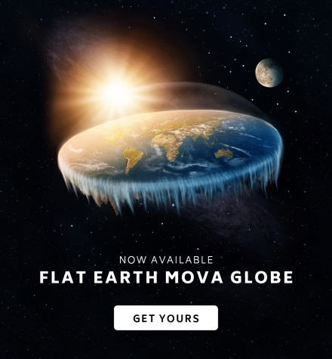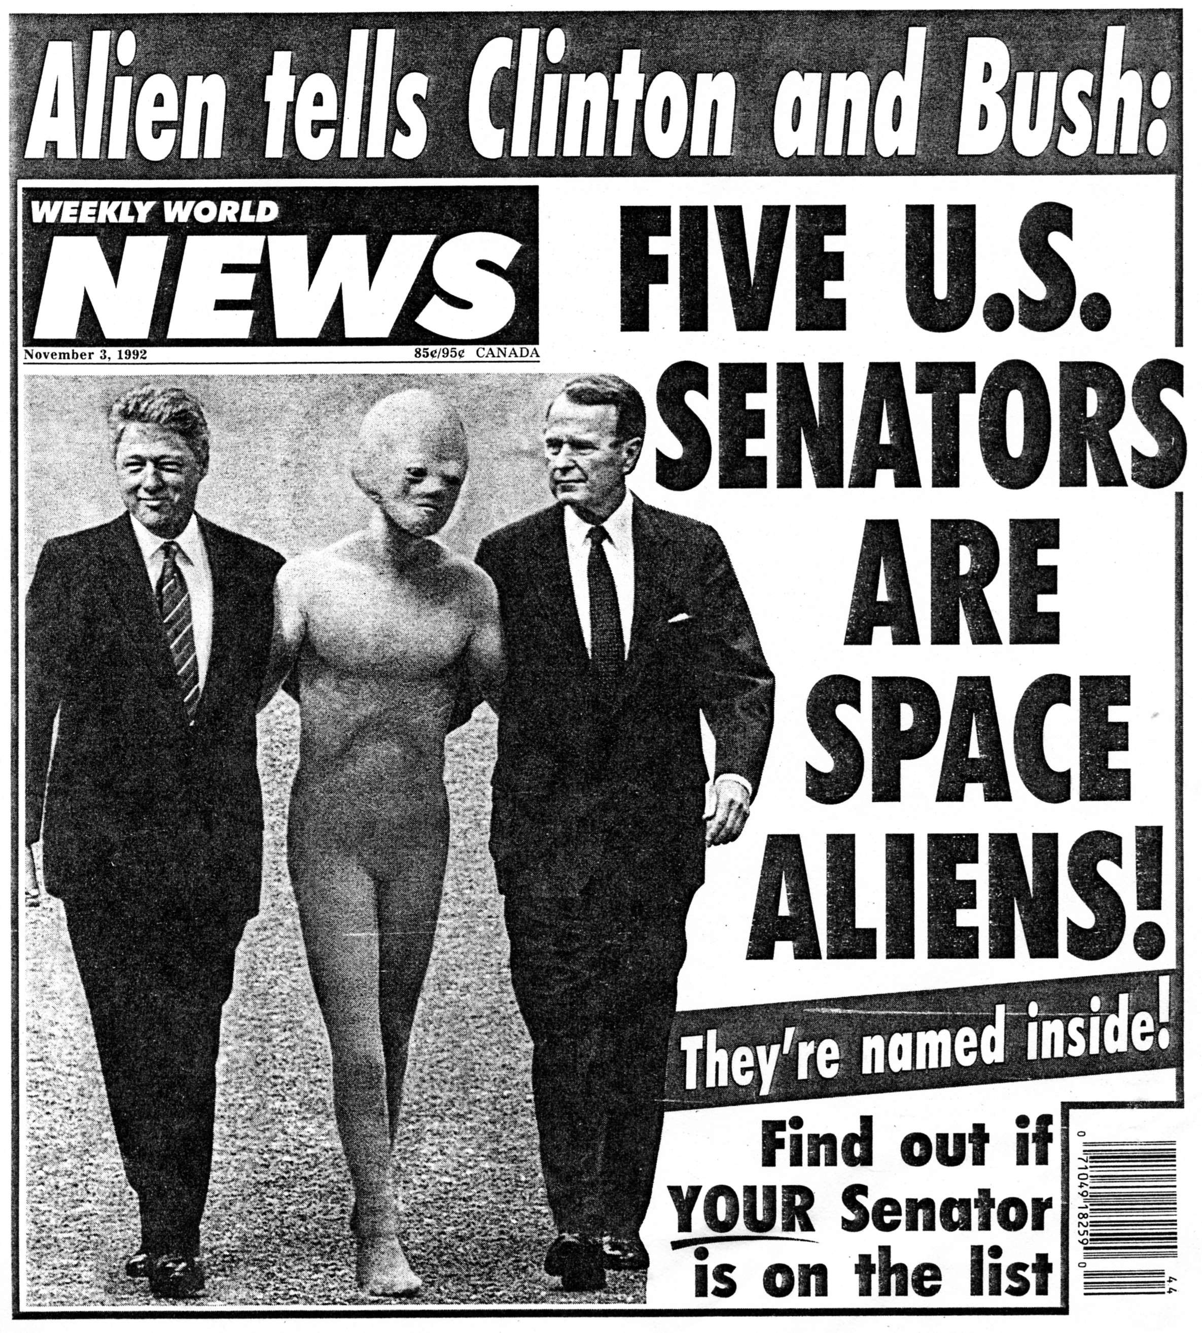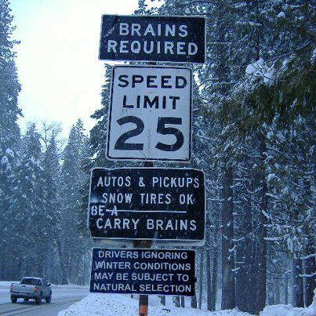

1. Astrology______________________________________________________________________

Perhaps the best known field of astronomical pseudo-science is the ancient idea that the position of the Sun, Moon, and planets at the moment we are born somehow affects our subsequent personality, career, or love-life. Astrology got a big media boost in 1988 when it was revealed that, for a large part of his term, President's Reagan's schedule had been controlled by the predictions of a San Francisco astrologer (who had been on Nancy Reagan's payroll.) However, astrology is also the field in which the largest number of scientific tests have been performed and the evidence clearly demonstrates that astrological connections are no more than wishful thinking.

Fraknoi, A. An Astronomer Looks at Astrology: https://www.astrosociety.org/astrology.pdf An introduction with some skeptical questions to ask.
Dawkins, R. The Real Romance in the Stars (1995 newspaper commentary attacking astrology): https://www.independent.co.uk/voices/the-real-romance-in-the-stars-1527970.html
Astrology and Science Web Site: http://www.astrology-and-science.com/index.htm Articles and research studies fill this crowded site, which is the single best place to examine the issues with astrology and the experiments that have been done seriously.
Plait, P. Bad Astronomy Page on Astrology: http://www.badastronomy.com/bad/misc/astrology.html (good analysis)
Dean, G., et al. Tests of Astrology. 2016, Aino Publ. http://www.astrology-and-science.com/U-aino2.htm (A massive volume, filled with information on experimental tests.)
Dean, G. “Does Astrology Need to be True?” in Skeptical Inquirer, Jul/Aug 2016, p. 38: https://skepticalinquirer.org/2016/11/does_astrology_need_to_be_true_a_thirty-year_update/?/si/show/does_astrology_need_to_be_true_a_thirty-year_update
Kelly, I. “Modern Astrology: A Critique” in Psychological Reports, November 1997: https://www.researchgate.net/publication/275866394_Modern_astrology_A_critique

2. UFO’s________________________________________________________________________

For decades the media have given enormous attention to sensational claims that vague lights in the sky are actually extra-terrestrial spacecraft. Over the years, the claims have grown to include crashes of such alien spacecraft and even kidnappings of unsuspecting Earth inhabitants by aliens. A sober examination of these claims reveals that there is a lot LESS to them than first meets the eye: when there is enough evidence, UFO claims can be explained by perfectly natural terrestrial or celestial phenomena (and, all too frequently, as deliberate hoaxes), while alien “abductions” mostly seem to take place in the mind of the victim or the gullible therapist.

McGaha, J. & Nickell, J. “The UFO Identification Process” from Skeptical Inquirer 2018: https://skepticalinquirer.org/2018/11/ufo_identification_process/
Fraknoi, A. UFO’s: A Lot Less than Meets the Eye (short overview): https://www.researchgate.net/publication/258377682_UFO's_A_Lot_Less_than_Meets_the_Eye
Gleick, J. The Doctor’s Plot. (A New York Times reporter examines critically the work of John Mack on UFO abductions): https://around.com/abduct.html
McGaha, J. & Nickell, J. “Alien Lights? At Phoenix, Stephenville & Elsewhere” from Skeptical Inquirer 2015 (explains some famous cases): https://skepticalinquirer.org/2015/03/alien_lights_at_phoenix_stephenville_and_elsewhere_a_postmortem/?/si/show/alien_lights_at_phoenix_stephenville_and_elsewhere_a_postmortem
Ian Ridpath UFO Skeptic Page: http://www.ianridpath.com/ufo/ufoindex.htm British science writer investigates UFO reports, and discusses astronomical causes of UFO sightings.
James Oberg’s Space Age Myths: http://www.jamesoberg.com/ufo.html Investigation of cases by a veteran space journalist. See video at: https://www.youtube.com/watch?v=kdkbJ-4r2ZY
Robert Shaeffer’s UFO Skeptic’s Page: http://www.debunker.com/ufo.html A big collection of investigations and skeptical examinations. Updated at: https://badufos.blogspot.com/
Mick West does excellent videos debunking some of the most famous recent cases: https://www.youtube.com/channel/UCF3UCTZiVg9wrIEzO7Om6jw
Philip Klass was arguably the most influential debunker of UFO’s. An excellent Wikipedia page traces his life and lists his writings: https://en.wikipedia.org/wiki/Philip_J._Klass
Alien Autopsy Hoax: https://skepticalinquirer.org/1995/11/alien-autopsy-hoax/ Debunking the famous video.
Apps to Create UFO Photos (from Skeptical Inquirer): https://skepticalinquirer.org/2013/11/ufo_hoaxes_theres_an_app_for_that/?/si/show/ufo_hoaxes_theres_an_app_for_that

3. Crop Circles____________________________________________________________________

Despite sensational claims of alien visitors making patterns in British wheat fields and other agricultural locations (a claim reinforced by the horror movie Signs), the evidence indicates that they are the work of earthly hoaxters. Both the number and complexity of the crop circles seems to increase with media coverage, and several teams of hoaxters in Europe and America have now confessed.

Nickell, J. Circular Reasoning (a good investigative report from Skeptical Inquirer 2002): https://skepticalinquirer.org/2002/09/circular-reasoning-the-mystery-of-crop-circles-and-their-orbs-of-light/
Radford, B. Crop Circles: A Not-so-Convincing Case (from Skeptical Inquirer 2014): https://skepticalinquirer.org/2014/09/crop_circles_a_not-so-convincing_case/ (See also a 2017 version at: https://www.livescience.com/26540-crop-circles.html )
The 2002 Crop Circle Experiments (CSI Archive): http://web.archive.org/web/20060707212846/http:/www.csicop.org/hoaxwatch/cropcircles.html
Crop Circles: The Art of the Hoax (from Smithsonian): https://www.smithsonianmag.com/arts-culture/crop-circles-the-art-of-the-hoax-2524283/

4. The “Face” on Mars______________________________________________________________

A popular "government conspiracy" theory held that NASA actually discovered a human face (as well as pyramids and other structures) on Mars, but is withholding crucial information from the public about the profound implications of this discovery. The real story is a lot less exciting, and involves a perfectly natural geologic formation on the red planet. In spring 1998, the Mars Observer spacecraft took a much more detailed close-up image of the region in question, and found no evidence of anything that looked unnatural or like a face.

Science at NASA Discussion of the “Face”: https://science.nasa.gov/science-news/science-at-nasa/2001/ast24may_1
Nola Taylor Redd “The Face on Mars: Fact and Fiction”: https://www.space.com/17191-face-on-mars.html
NBC News: New View of the Face on Mars: http://www.nbcnews.com/id/3077691/ns/technology_and_science-space/t/new-view-famous-face-mars/#.XMp1OzBKiiR
Stephens, Sally: The Face on Mars (for teachers): https://astrosociety.org/edu/publications/tnl/25/25.html
More “faces” on Mars in old images: http://www.tampabayskeptics.org/Mars_morefaces.html

5. The Full Moon and Lunacy________________________________________________________

The idea that more crazy behavior takes place during a full moon is well ingrained in folk wisdom. Statistical tests, however, show that there is no such effect, except perhaps in the mind of witnesses (perhaps influenced by legends that associate the Sun with good and the Moon with evil.) Since the full moon is bright and up all night long, it is more likely to reveal events that also happen during other phases of the Moon, but are more likely to go undetected.

Moonstruck (a website by Dr. Eric Chudler, U of Washington, reviewing and explaining many “lunacy” studies: http://faculty.washington.edu/chudler/moon.html
Full Moon and Lunar Effects: http://skepdic.com/fullmoon.html (Part of the Skeptical Dictionary site).
Bad Moon Rising: The Persistent Belief in Lunar Connections to Madness (from the Canadian Medical Association Journal): https://www.researchgate.net/publication/7438277_Bad_Moon_Rising_the_persistent_belief_in_lunar_connections_to_madness
Rotton, J. & Kelly, I. “Much Ado About the Full Moon: A Meta-Analysis of Lunar-Lunacy Research” from Psychological Bulletin 1985 (a classic study): https://www.researchgate.net/profile/Ivan_Kelly2/publication/19277222_Much_Ado_About_the_Full_Moon_A_Meta-Analysis_of_Lunar-Lunacy_Research/links/5879338f08ae9275d4d94885/Much-Ado-About-the-Full-Moon-A-Meta-Analysis-of-Lunar-Lunacy-Research.pdf

6. The “Great Moon Hoax”: Did Astronauts Land on the Moon____________________________

A small group of “conspiracy theorists” who claim that NASA never landed people on the Moon got a big boost in 2001, when the Fox network broadcast a long paranoid show about their ideas. The web sites below provide a skeptical examination of this claim and the so-called evidence for it. From the many moon rocks brought back by the astronauts to the instruments they left on the Moon, there was always ample evidence that the moon landings actually happened. In 2009, the Lunar Reconnaissance Orbiter took direct images showing the Apollo artifacts on the Moon.

Phil Plait’s response to Fox’s “Moon Hoax” Show (part of his Bad Astronomy website): http://www.badastronomy.com/bad/tv/foxapollo.html
Hoax TV show comments by astronomer Jim Scotti (useful analysis): https://pirlwww.lpl.arizona.edu/~jscotti/NOT_faked/
Moon Base Clavius Site (a group effort at debunking): http://www.clavius.org/site.html
National Geographic Slide Show of Apollo images explaining why they are NOT fake: https://news.nationalgeographic.com/news/2009/07/apollo-11-hoax-photos--8-moon-landing-myths-busted/
Astronomer Ethan Siegel’s article on proofs we did land: https://medium.com/starts-with-a-bang/heres-your-proof-that-we-landed-on-the-moon-steph-curry-3eaa2ada1209
Adam Ruins Everything (5 min video that gives a number of reasons why the moon landing could not have been faked): https://www.youtube.com/watch?v=zhp-FTYSGe8

7. Creationist Astronomy/Young Universe Theory______________________________________

Fundamentalist religious thinkers (from a number of religions) have sought to deny the evidence from geology, astronomy, and evolutionary biology about the age and gradual development of the universe, the Earth, and its life-forms. Some groups have worked hard to get their own brand of “creation science” or “intelligent design” into the public schools and thus undermine the teaching of evolution, one of the most fundamental and best-established ideas in modern science. (Recent creationist tactics have involved attacking the Big Bang theory and the age of the universe.) The literature examining this controversy is enormous; the list below is merely a representative sampling, of particular interest to astronomy educators.

Fraknoi, A., et al: An Ancient Universe: How Astronomers Know the Vast Scale of Cosmic Time (a booklet for teachers and the public from the American Astronomical Society): https://aas.org/education/ancientuniverse
Moore, D. Supernovae & Young Earth Creationism: http://www.talkorigins.org/faqs/supernova/
Bobrowsky, M. “Dealing with Disbelieving Students on Issues of Evolutionary Processes & Long Time Scales” from Astronomy Education Review: http://dx.doi.org/10.3847/AER2005007
The Age of the Earth: http://www.talkorigins.org/faqs/faq-age-of-earth.html Explains how we measure the age of our planet; dissects some of the common creationist arguments for a younger Earth.
Changing the Speed of Light Analysis (how to deal with suggestions that the speed of light has changed over cosmic time): http://www.talkorigins.org/faqs/c-decay.html
National Center for Science Education: Best site for keeping up with creationism issues from the science perspective.
Teaching about Evolution and the Nature of Science. A free 1998 book from the National Academy of Science: https://www.nap.edu/read/5787/chapter/1
Eugenie Scott: Creationism: Still Crazy After All These Years (a 2009 video): https://www.youtube.com/watch?v=pItVGYa863k (This is just one of many videos on line by Scott, who is the foremost scientist leading the charge for evolution and against creationism.)

8. Ancient Astronauts and Erich Von Daniken___________________________________________

A convicted Swiss embezzler (who wrote part of his best-selling Chariots of the Gods while in jail), Von Daniken claimed that a large amount of archaeological evidence supports that alien visitors helped us build many of the impressive artifacts that ancient civilizations left behind. (The insulting subtext here is that we needed the aliens' help because we humans were too stupid to build the Nazca lines or the pyramids by ourselves.) In fact, Von Daniken's books involve massive misinterpretations of archaeological data and a great deal of fabrication. Although his books are no longer as popular as they once were, his ideas have been incorporated into many new pseudo-science tracts and irresponsible television “pseudo-documentaries.”

Sheaffer, R. Science or Charlatanism: http://www.debunker.com/texts/vondanik.html
Omohundro, J. Von Daniken’s Chariots: A Primer in Cooked Science (from Skeptical Inquirer, 1976): https://skepticalinquirer.org/1976/10/von-danikens-chariots-a-primer-in-the-art-of-cooked-science/
Story, R. Von Daniken’s Golden Gods (from Skeptical Inquirer, 1977): https://skepticalinquirer.org/1977/10/von-danikens-golden-gods/
Skeptic’s Dictionary entry on ancient astronauts: http://skepdic.com/vondanik.html
National Geographic brief introduction to the Nasca Lines of Peru: https://www.nationalgeographic.com/archaeology-and-history/archaeology/nasca-lines/
Ancient Aliens Debunked: a 3-hour film by Chris White showing the many errors in the History Channel Ancient Aliens series: https://www.youtube.com/watch?v=j9w-i5oZqaQ

9. Astronomical Doomsdays _____________________________________________________

Several times in recent years an announcement has come that the Earth would experience world-wide catastrophe, from a collision or from some other astronomical cause. NASA’s David Morrison has coined the term “cosmophobia” for the fear of astronomical disasters, and it appears that cosmophobia remains a worry, despite the absence of any evidence for the world ending in 2012 or at any other modern time.

Cosmophobia Site (maintained by a group of dedicated amateur astronomers): http://www.cosmophobia.org/index.html (The page about David Morrison’s work on this site is at: http://www.cosmophobia.org/david_morrison/index.html )
NASA: Beyond 2012: Why the World Didn’t End: https://www.nasa.gov/topics/earth/features/2012.html
David Morrison: End of the World in 2012 Fact Sheet: https://lunarscience.nasa.gov/articles/doomsday-2012-fact-sheet/
Phil Plait on Planet 9 & Doomsday: https://slate.com/technology/2016/04/fearmongering-articles-claim-planet-nine-might-kill-us-all.html
Doomsday entry in the Skeptic’s Dictionary: http://skepdic.com/doomsday.html

10. The Flat Earth_______________________________________________________________

Here’s one idea no astronomer expected to make a come-back in the 21st century – the media is again featuring people who claim the Earth is flat. Where this comes from and how to respond is now something a number of our sources are looking into.

Burdick, A. “Looking for Life on a Flat Earth” in The New Yorker, May 30, 2018: https://www.newyorker.com/science/elements/looking-for-life-on-a-flat-earth
Fraknoi, A., et al. Astronomy. 2016, OpenStax. http://openstax.org/details/astronomy See chapter 2, section 2 of this free on-line textbook for a discussion of how we know the Earth is round.
Loxton, D. “Is the Earth Flat?” from The Skeptic: https://www.skeptic.com/insight/flat-earth-conspiracy-theory/
Schottlender, M. “10 Easy Ways You Can Tell for Yourself that the Earth is not Flat” in Popular Science: https://www.popsci.com/10-ways-you-can-prove-earth-is-round
Big Picture Science Radio Show Episode on the Flat Earth Controversy: http://bigpicturescience.org/episodes/skeptic-check-flat-earth

11. Miscellaneous Topics in Astronomical Pseudoscience_______________________________

Naming Stars for Money is a Scam (from the International Astronomical Union): https://www.iau.org/public/themes/buying_star_names/ (Also see this Universe Today column: https://www.universetoday.com/104134/can-you-really-name-a-star/ )
Hale, A. "Hale-Bopp Comet Madness" in Skeptical Inquirer, Mar/Apr. 1997, p. 25. On a cult that saw a spaceship behind the comet: https://skepticalinquirer.org/1997/03/hale-bopp-comet-madness/
Eades, J. Anti-matter Pseudoscience: https://skepticalinquirer.org/2012/03/antimatter-pseudoscience/ (looking at claims that antimatter is practical for solving our energy needs)
McDaid, L. “Legends of the Dogon: Mystery Resurfaces” (claims that an African tribe knew astro-nomy only visible through larger telescopes): https://www.skeptic.com/eskeptic/10-01-13/
The Velikovsky Affair (two articles about the European “scholar” who thought violent collisions in recent times had shaped the solar system): https://skepticalinquirer.org/1980/10/ideas-in-collision/ and https://skepticalinquirer.org/1980/10/the-distortions-continue/ (A detailed analysis by a former supporter is: http://defendgaia.org/bobk/velidelu.html )

12. General Resources for Debunking Pseudoscience____________________________________

The Committee for Skeptical Inquiry (CSI) is an international group of scientists, magicians, educators, doctors, and others committed to rational investigation of claims of the paranormal. They publish the magazine Skeptical Inquirer, which offers a number of its articles and news stories free on the Web: https://skepticalinquirer.org/
The Skeptic Society: Another, smaller group of skeptics, which publishes The Skeptic magazine and offers articles, video, e-news and more: https://www.skeptic.com/
The Skeptic’s Dictionary by Robert Carroll: a web-based (and published) survey of claims of the supernatural and what skeptics reply (with many links to more expansive discussions): http://skepdic.com/

