Some Plays (and Films) about Astronomers
A Listing by Andrew Fraknoi (Fromm Institute, U. of San Francisco)

© Copyright 2023 by Andrew Fraknoi. The right to distribute for a non-profit educational purpose, such as a class, is hereby granted. For any other use, contact the author: fraknoi {at} fhda {dot} edu

NOTE: This is a first attempt at compiling a list of plays and films about astronomers. No claim is made for completeness and additional suggestions are most welcome. (A list of operas and other music about astronomers is included in my topical listing of astronomy-inspired music: http://bit.ly/astronomymusic )

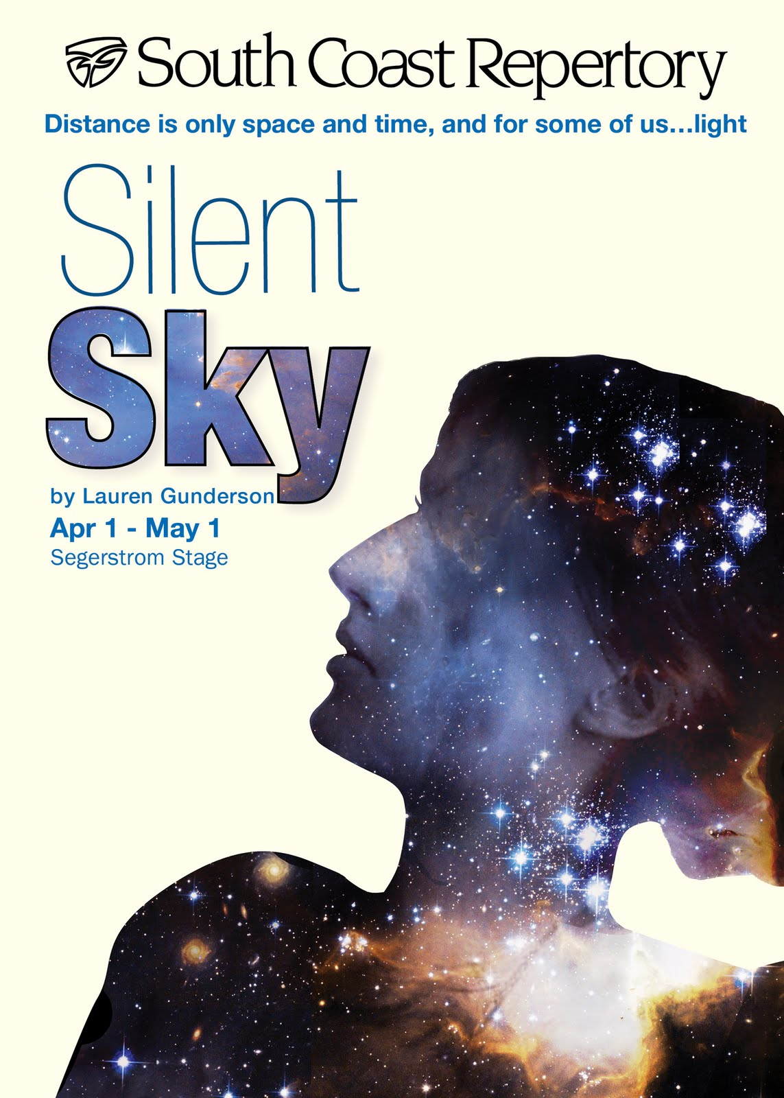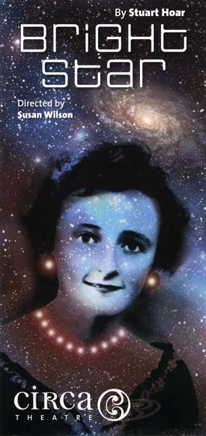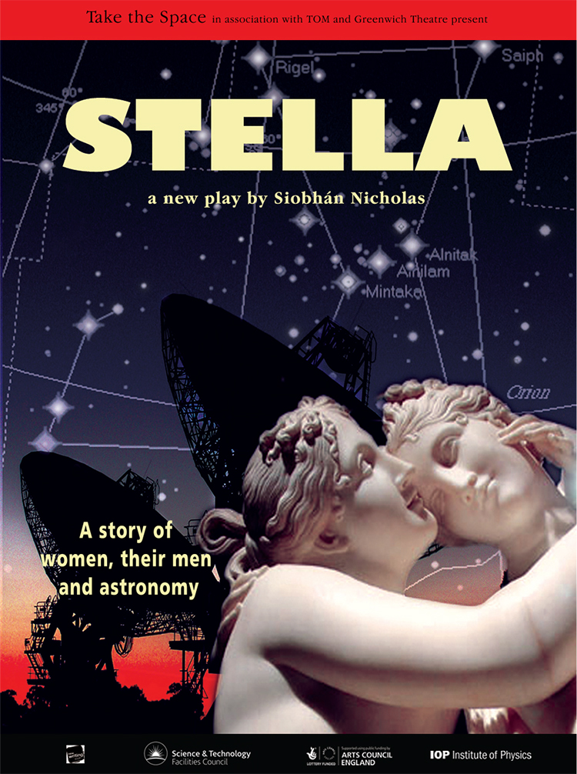

PLAYS ABOUT (OR FEATURING) ASTRONOMERS:

✪ Chemers, Krumholz, and Bierman: Birth of Stars. This experimental play, one of whose authors (Mark Krumholz) is an astronomer, performed at the U. of California, Santa Cruz, has a teenage astronomy prodigy as its protagonist, and deals with her life and her obsession with the lives of stars: https://news.ucsc.edu/2014/10/stars-art-science.html and https://www.cityonahillpress.com/2014/11/14/parallel-lives-of-humans-and-stars/
Hailey Shapiro’s thesis analyzing the play and its educational effects is available: https://escholarship.org/content/qt6tf6c312/qt6tf6c312.pdf

✪ Coughran, Bruce: A Time for Hawking. 2022, Indra’s Net Theater Press. A play about the young Hawking, before his illness was diagnosed, and Jayant Narlikar. A review of the first production is at: https://datebook.sfchronicle.com/theater/indras-nets-a-time-for-hawking-an-uneasy-mix-of-theater-lecture

✪ Gabridge, Patrick: Reading the Mind of God (a play about Johannes Kepler and Tycho Brahe). The text can be found at: http://webs.wofford.edu/zidessb/Theatrefiles/reading%20the%20mind%20of%20god.pdf
A synopsis and history of productions is at: http://www.gabridge.com/full-length-plays/reading-the-mind-of-god/

✪ Goldhaber, Judith & Pennypacker, Carl: Falling through a Hole in the Air (a musical play about Stephen Hawking): http://www.psyclops.com/hawking/ccsf_play/falling.shtml
(A song from the play is performed here: http://www.youtube.com/watch?v=UXjwZIqJwos )

✪ Goodwin, Richard The Hinge of the World: In Which Professor Galileo Galilei, Chief Mathematician and Philosopher to His Serene Highness the Grand Duke of Tuscany, and His Holiness Urban VIII Battle for the Soul of the World. (A 1998 play by a former Kennedy White House advisor, published Farrar Straus & Giroux; performed as Two Men of Florence, with a study guide available at
https://issuu.com/thomdunn/docs/two_men_of_florence_final)

✪ Gunderson, Lauren: Silent Sky (about astronomer Henrietta Leavitt): https://sites.google.com/site/henriettasrhapsody/ and http://silentskyplay.tumblr.com/
For more about the dramatist: http://laurengunderson.com/

✪ Gunderson, Lauren: Background (about Ralph Alpher and getting credit for the prediction of the cosmic microwave background radiation.) The text of the play is available in the author’s compilation Deepen the Mystery: Science and the South Onstage (2005, I Universe), which also includes a short comic play about Isaac Newton.

✪ Hawdon, Robin: God and Stephen Hawking. 2002, Josef Weinberger Plays. (A controversial play about Hawking’s life and science, wherein God appears as Newton, Einstein, and others): https://robinhawdon.com/robin-hawdon-plays/god-and-stephen-hawking/

✪ Hoar, Stuart (a New Zealand playwright): Bright Star (a play about the work and life of astronomer Beatrice Tinsley): https://www.stuff.co.nz/entertainment/stage-and-theatre/106836905/bright-star-science-legends-shining-achievement-on-the-stage and
http://www.playmarket.org.nz/playwrights/stuart-hoar

✪ Hood, Kevin The Astronomer’s Garden (a play about John Flamsteed and Edmund Halley)
Printed version available: http://www.amazon.co.uk/Astronomers-Garden-Beached-Theatrescripts-Modern/dp/0413650804

✪ Hunter, Maureen The Transit of Venus (a play about Guillaume Le Gentil and the effect of his travels on his loved ones). See: http://www.amazon.com/Transit-Venus-Scirocco-Maureen-Hunter/dp/1897289138/ and https://en.wikipedia.org/wiki/Transit_of_Venus_(play) (The play became an opera as well: https://en.wikipedia.org/wiki/Transit_of_Venus_(opera)

✪ Kovacsik, William: Vera Rubin: Bringing the Dark to Light is a new two person play that involves audio-visual effects on the dome of a planetarium; it had its premiere in Boulder’s Fiske Planetarium in 2015: http://www.dailycamera.com/entertainment/ci_29381031/boulder-ensemble-theatre-company-fiske-planetarium-present-vera-rubin-bringing-light-dark OR https://www.denverpost.com/2016/01/14/vera-rubin-performance-a-collaboration-of-betc-and-fiske-planetarium/

✪ Lonergan, Kenneth: The Starry Messenger (about an astronomy instructor at the old Hayden Planetarium on the eve of its being torn down, was staged in NY with Matthew Broderick): http://variety.com/2009/legit/reviews/the-starry-messenger-1200477294/ or http://www.nytimes.com/2009/11/24/theater/reviews/24starry.html?_r=0

✪ Mighton, John: A Short History of Night. 2007, Playwrights Canada Press. (A play about Johannes Kepler and Tycho Brahe, and the beginnings of science; by a Canadian professor): https://www.playwrightscanada.com/Books/A/A-Short-History-of-Night

✪ Miyagawa, Chiori: Comet Hunter (about Caroline Herschel) See: http://archive.ttbook.org/book/chiori-miyagawa-and-jim-lattis-comet-hunter

✪ Nicholas, Siobhán: Stella (another play about Caroline Herschel): http://www.guardian.co.uk/science/blog/2012/may/14/play-astronomer-caroline-herschel

✪ Pachino, Jamie: Splitting Infinity (a woman astrophysicist, a rabbi who has known her since childhood, and her Christian Scientist post-doc explore the boundaries between science and religion and the existence of God) Review: https://www.sfgate.com/performance/article/Theater-review-Splitting-Infinity-3189007.php About the Playwright: http://www.jamiepachino.com/Home

✪ Padamsee, Hassan Creation’s Birthday (a play about Hubble’s life and work). See:
http://www.indiegogo.com/projects/creation-s-birthday-a-play-by-professor-hasan-padamsee-of-cornell-university OR https://news.fnal.gov/2012/07/creation-s-birthday-brings-edwin-hubble-s-contentious-life-to-the-fermilab-stage/

✪ Payne, Nick Constellations - A 2015 play, published by Farrar, Straus, and Giroux; the female character in the two-person play specializes in “theoretical early universe cosmology.” (See a review at: https://www.nytimes.com/2015/01/14/theater/constellations-with-jake-gyllenhaal-and-ruth-wilson-opens-on-broadway.html)

✪ Sobel, Dava (author of Longitude and Galileo’s Daughter) has written a play about Copernicus called “And the Sun Stood Still”, which she discusses and includes in her book, A More Perfect Heaven (2011, Walker Books.) For her discussion of how she came to write the play, see: http://astrosociety.org/wp-content/uploads/2013/02/ab2011-83.pdf

✪ Sparks, John & Alben, Russ The Smartest Man in the World (a musical about Albert Einstein, performed briefly in Los Angeles). See: http://www.curtainup.com/smartestmanla.html

✪ Stoppard, Tom Galileo. 2003, Arete. (This is the full text of a previously unpublished and unperformed play written in 1970 by an internationally renowned playwright who often incorporates scientific ideas in his plays.)

✪ Rappaport, M. & Corbally, C. Space Science and Astronomy Theater. 2017, Archway. This unusual book features a collection of drama scenes about astronomical history, issues, and ideas that students can perform as part of a class. Corbally is an astronomer. See: https://www.archwaypublishing.com/Bookstore/BookDetail.aspx?BookId=SKU-001134041

✪ Operas about astronomers include: Einstein on the Beach, Galileo Galilei, and Kepler by Philip Glass and The Harmony of the World by Paul Hindemith (about Kepler.)
__________________________________________________________________________________

A FEW OLDER PLAYS:

✪ Bertold Brecht’s Life of Galileo (1994, Grove Press reprint English edition), a 1938 play about Galileo’s discoveries and how they upended the establishment views of nature and our place in it. See also the 1974 DVD of the filmed version directed by Joseph Losey, and starring Topol as Galileo, available on King Video (http://www.imdb.com/title/tt0073029/ )
For more about the play, see: https://en.wikipedia.org/wiki/Life_of_Galileo

✪ Barrie Stavis’s The Lamp at Midnight (1947 play about Galileo and his conflict with the Church): https://en.wikipedia.org/wiki/Lamp_At_Midnight
For a video of the revival, see : http://www.imdb.com/title/tt0197613/

✪ Good News -- a 1927 musical, book: Laurence Schwab and B.G. DeSylva, lyrics: DeSylva and Lew Brown, and music by Ray Henderson. In the 1920s at Tait College, football player Tom Marlowe falls in love with Connie Lane, who is tutoring him so he can pass astronomy and be eligible to play in the big game. The astronomy professor has a role in the madcap plot as well. https://en.wikipedia.org/wiki/Good_News_(musical)
__________________________________________________________________________________
SOME MOVIES ABOUT (OR FEATURING) ASTRONOMERS (a very incomplete list):

Addicted to Love. (Matthew Broderick plays an astronomer in this 1997 romantic comedy from the U.S., but the astronomy is completely incidental): http://www.imdb.com/title/tt0118556/plotsummary

Contact (Jodi Foster plays Ellie Arroway, a radio astronomer based on Jill Tarter, in this 1997 film adaptation of Carl Sagan’s novel): https://en.wikipedia.org/wiki/Contact_(1997_US_film)

Corpos Celestes (The Sky We Were Born Under) (A Brazilian film about an unhappy astronomer with a complex past): https://www.imdb.com/title/tt0814062/

Deep Impact (a 1998 disaster movie about a comet on collision course with Earth, with Elijah Wood playing a teenage amateur astronomer, and Charles Martin Smith playing a professional astronomer.) See: https://en.wikipedia.org/wiki/Deep_Impact_(film) and https://io9.gizmodo.com/a-scientist-responds-to-deep-impact-1709206458

Einstein and Eddington (2008, BBC Film) Biographical dramatization of the intersection of their two lives and the 1919 proof of the General Theory of Relativity. Can currently be streamed on HBO Max. A brief review is at: https://physicsworld.com/a/einstein-and-eddington-film/

The Heavenly Body (a 1944 comedy, where William Powell plays an astronomer whose neglected wife, Hedy Lamarr, turns to an astrologer for advice about her romantic life): http://www.imdb.com/title/tt0035980/

Interstellar (2014 science fiction film from an idea by, and in consultation with, Nobel Laureate Kip Thorne; features black holes, worm holes, and several characters as physicists working in this area.) See, for example: https://www.wired.com/2014/10/astrophysics-interstellar-black-hole/all/1/ or https://www.space.com/27692-science-of-interstellar-infographic.html or https://blogs.scientificamerican.com/observations/parsing-the-science-of-interstellar-with-physicist-kip-thorne/
Kip Thorne has written a book called The Science of Interstellar. 2014, Norton.

Roxanne (a 1987 US film that modernizes Cyrano de Bergerac, has Daryl Hannah as an astronomer who comes to a small town to look at a comet: https://en.wikipedia.org/wiki/Roxanne_(film) )

The Theory of Everything (2014 film in which Eddie Redmayne won an Oscar for playing Stephen Hawking; is about Hawking’s graduate school career, discovery of his illness, marriage, etc. See: https://en.wikipedia.org/wiki/The_Theory_of_Everything_(2014_film) )

Thor (2011 film from the Marvel comic book series, in which Natalie Portman plays an astrophysicist who is Thor’s love interest. The film mixes Nordic mythology with science (including wormholes).

Top Gun (1986 film in which Kelly McGillis plays an astrophysicist who is also an Air Force pilot trainer)
_____________________________________________________________________________________

SOME RELEVANT ARTICLES:

Gandolfi, G. “Stars and Theater: From Renaissance Stage Astrologers to Astronomy-Flavored Science Plays” from Mediterranean Archeology and Archeometry, 2018: https://www.academia.edu/38147750/Stars_and_Theatre._From_Renaissance_Stage_Astrologers_to_Astronomy-flavored_Science_Plays

Stoppard, T. "Playing with Science" in Engineering & Science (Caltech), Fall 1994, p. 3. The brilliant playwright who uses science ideas regularly shares some of his thoughts. See also: Physics in the Plays of Tom Stoppard: http://physicsbuzz.physicscentral.com/2009/10/theater-for-physics-fans-and-physics.html

Usher, P. "Shakespeare's Cosmic World View" in Mercury (the popular-level magazine of the Astronomical Society of the Pacific), Jan/Feb. 1997, p. 20: https://www.academia.edu/36915987/Shakespeares_Cosmic_World_View

For lists of plays about science in general, see such web sites as:
- http://kasmana.people.cofc.edu/MATHFICT/search.php?go=yes&medium=pl&orderby=title
- http://www.curtainup.com/scienceplays.html
- https://sciart.commons.gc.cuny.edu/staging-science/four-centuries-of-science-plays/
- http://scienceplays.org/

A listing of films that feature characters who are astronomers can be found at: https://bestsimilar.com/tag/17845-astronomer

